***RESTAURENT WEBSITE***



***SUBMTTED BY:***

Muhammad Hassan 2025-CS -106

Rehan Ilyas 2025-CS-65

Ali Fayyaz 2025-CS-76

***SUBMITTED TO:***

Sir Moazam

***Dated:***

08-01-2026

Department of Computer Science

**University of Engineering and Technology, Lahore**

*Table of Contents*

*1.* *Introduction:* 3

*2.* *Objectives:* 3

*3.* *Tools used:* 3

*4.* *Website pages explanation:* 4

• ***HOME SCREEN:*** 4

• ***ABOUT :*** 6

• ***SERVICES PROVIDED :*** 6

• ***CONTACT:*** 7

*5.* *SQL {Theoretical}:* 7

• ***Customers:*** 7

➢ ***Create and insert:*** 7

➢ ***Update:*** 7

➢ ***Delete:*** 7

• ***Menu Items:*** 8

➢ ***Create and insert:*** 8

8

➢ ***Update:*** 8

➢ ***Delete:*** 8

• ***ORDERS STATUS:*** 8

➢ ***Create and Insert:*** 8

➢ ***Update:*** 9

➢ ***Delete:*** 9

*6.* *SQL Queries:* 9

• ***TABLE 1:*** 9

➢ ***Create & Insert:*** 9

➢ ***Update & Delete:*** 9

• ***TABLE 2:*** 10

➢ ***Create & insert:*** 10

➢ ***Update & Delete:*** 10

• ***TABLE 3:*** 11

➢ ***Create & Insert:*** 11

➢ ***Update & Delete:*** 11

*7.* *Canva designs:* 12

❖ ***Banner design:*** 12

❖ ***Logo design:*** 13

❖ ***Poster design:*** 13

*8.* *GitHub Repository:* 13

*9.* *Conclusion:* 13

# *Introduction:*

The First Semester Project Showcase Website is a static web-based platform developed to present final year projects in a professional and organized manner. The **Food Hub** website **allows** customers to easily browse the menu, place demo orders, and submit feedback or complaints through a simple online form. It also allows users to track their complaint status in real-time and find direct contact information or social media links to stay connected with the restaurant.

This project demonstrates basic knowledge of HTML, CSS, SQL concepts, Canva designing, and GitHub usage. It is designed for educational purposes and showcases how web technologies are used together in real-world projects.

# *Objectives:*

The main objectives of this project are:

* To design a simple and responsive website using HTML and CSS
* To understand basic database concepts using SQL (theoretical)
* To practice CRUD operations (Create, Read, Update, Delete)
* To create basic designs using Canva
* To upload and manage the project using GitHub
* To document the complete work in a clear and simple manner

# *Tools used:*

The following tools and technologies were used:

* + HTML – Structure of the website
  + CSS – Styling and layout
  + SQL – Database design (theoretical)
  + Canva – Banner, logo, and poster design
  + GitHub – Version control and project hosting
  + VS Code / Notepad – Code editor
  + Web Browser – Testing the website.

# *Website pages explanation:*

## ***HOME SCREEN:***

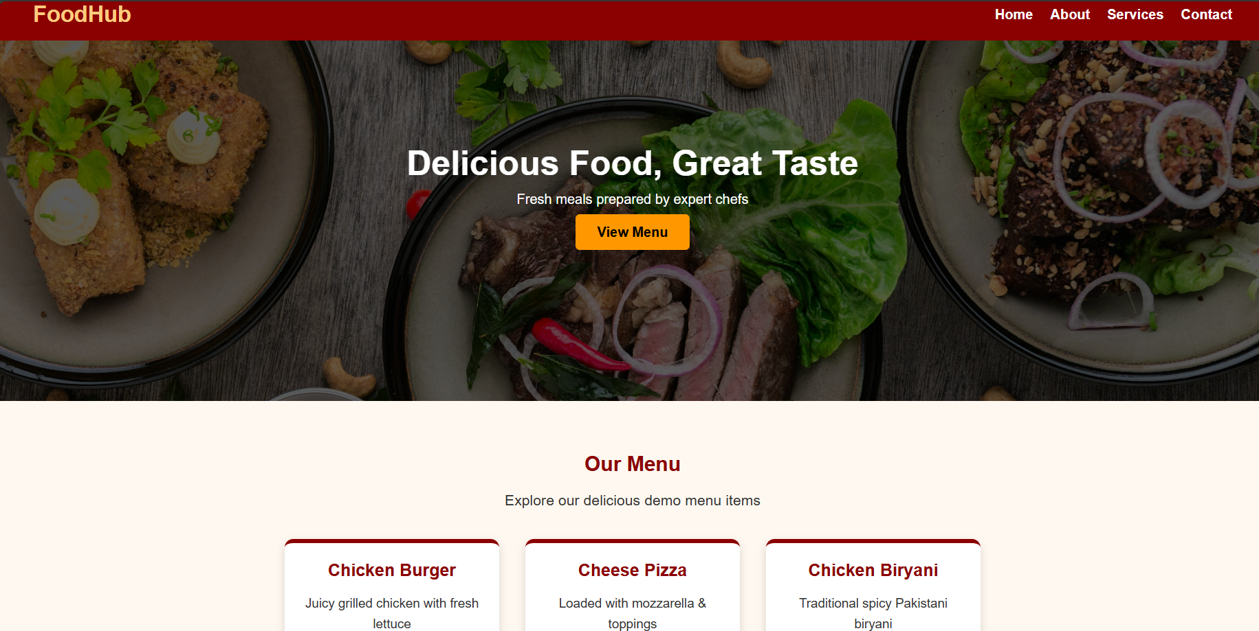

* **Brand Identity:** Displays the "Food Hub" restaurant name and a welcoming theme centered on "Delicious Food, Great Taste".
* **Navigation Menu:** Provides quick links to Home, About, Services, and Contact sections.
* **Visual Menu Gallery:** Showcases popular items like Chicken Burgers, Cheese Pizzas, and Chicken Biryani.
* **Action Button:** Features a prominent "View Menu" button to guide users to food options.

### ***HOME.html:***

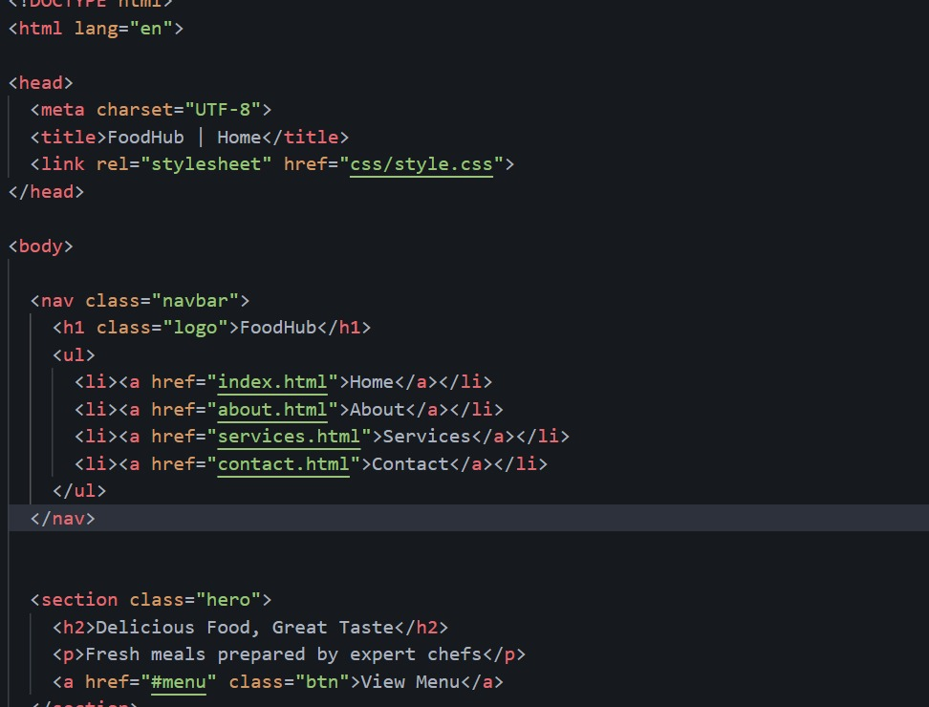

## ***ORDER:***

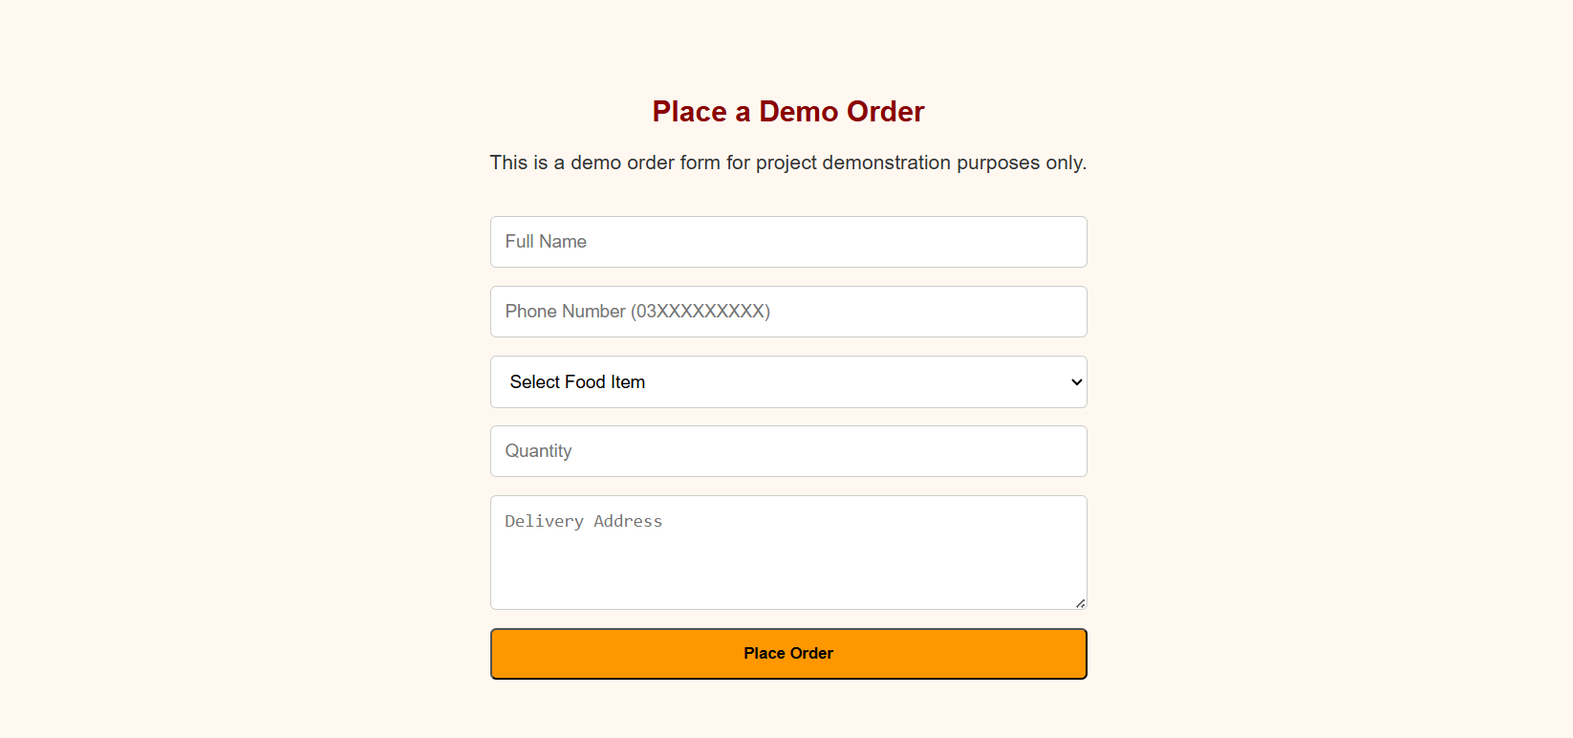

* **Demo Order Form:** Clearly states the form is for project demonstration purposes.
* **User Input Fields:** Collects the customer's Full Name, Phone Number, Food Item selection, and Quantity.
* **Delivery Details:** Includes a text area for the customer to provide their Delivery Address.
* **Submission Button:** Features a prominent orange "Place Order" button.

### ***ORDER.html:***



## ***ABOUT :***

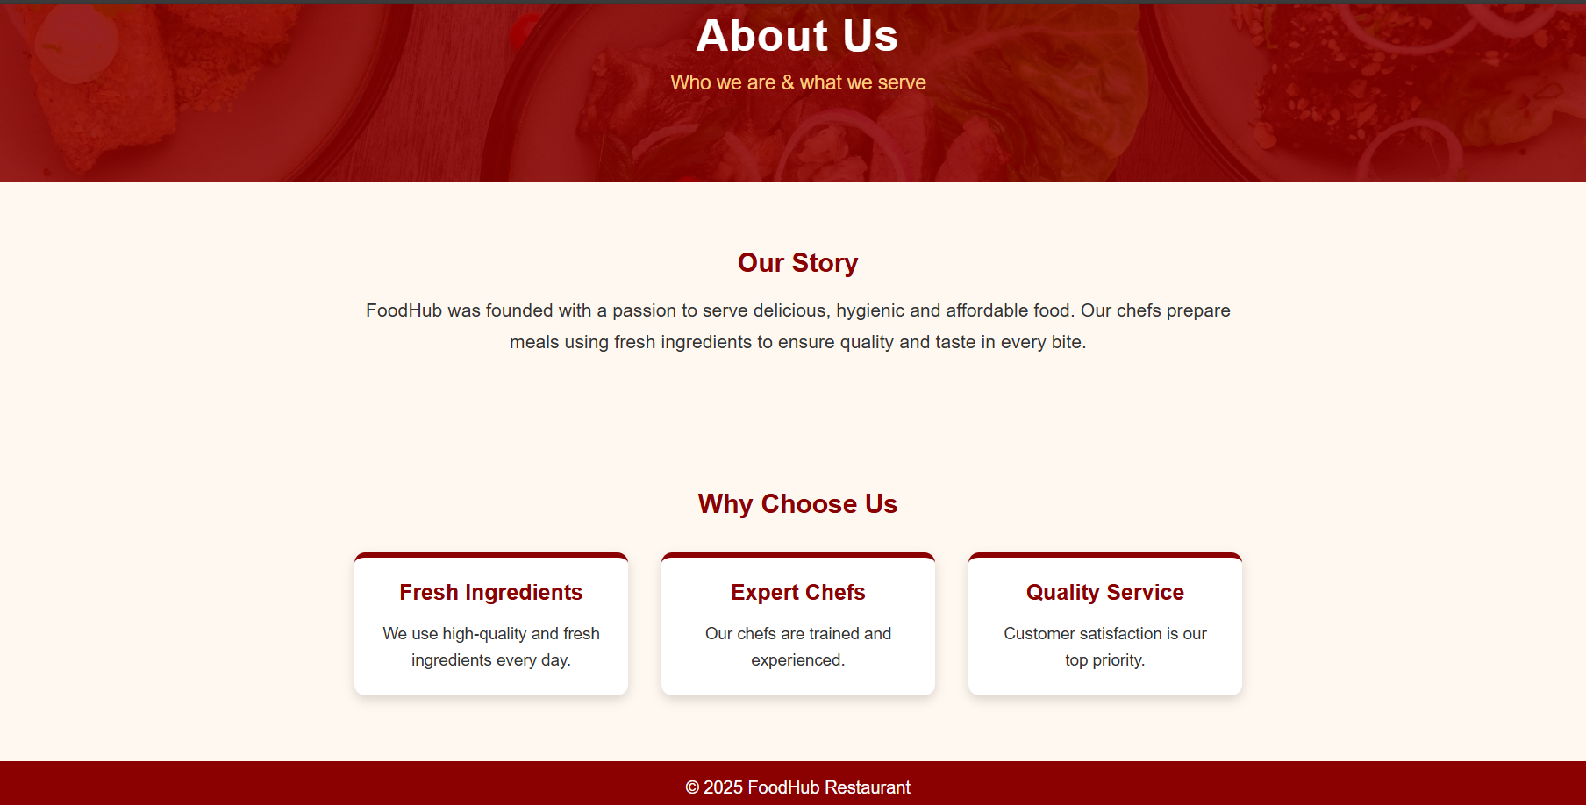

* **Our Story:** Describes Food Hub’s passion for serving fresh, hygienic, and affordable meals.
* **Why Choose Us:** Highlights three key pillars: Fresh Ingredients, Expert Chefs, and Quality Service.
* **Brand Mission:** Emphasizes that customer satisfaction is the top priority.

### ***ABOUT.html:***

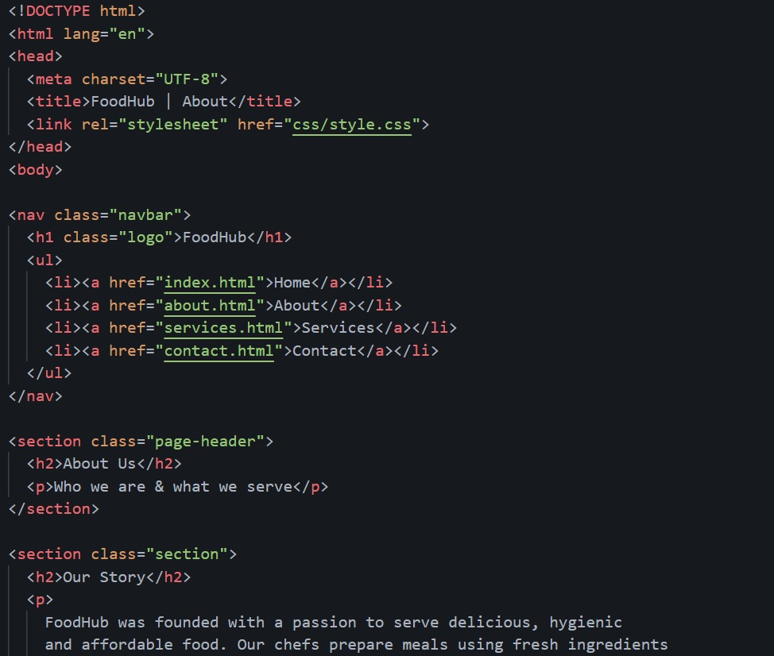

## ***SERVICES PROVIDED :***

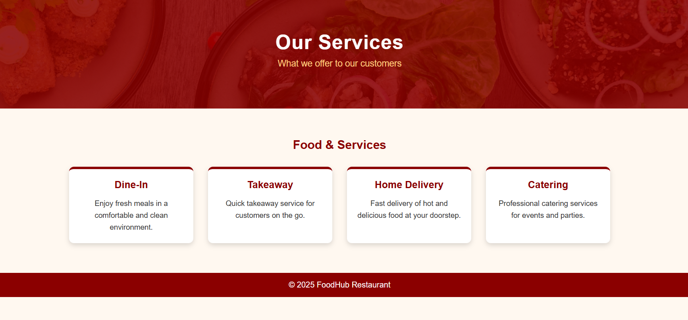

* **Dine-In:** Mentions enjoying fresh meals in a clean and comfortable environment.
* **Takeaway:** Offers a quick service option for customers on the move.
* **Home Delivery:** Promises fast delivery of hot food directly to the customer's door.
* **Catering:** Provides professional food services for special events and parties.

### ***SERVICES.html:***

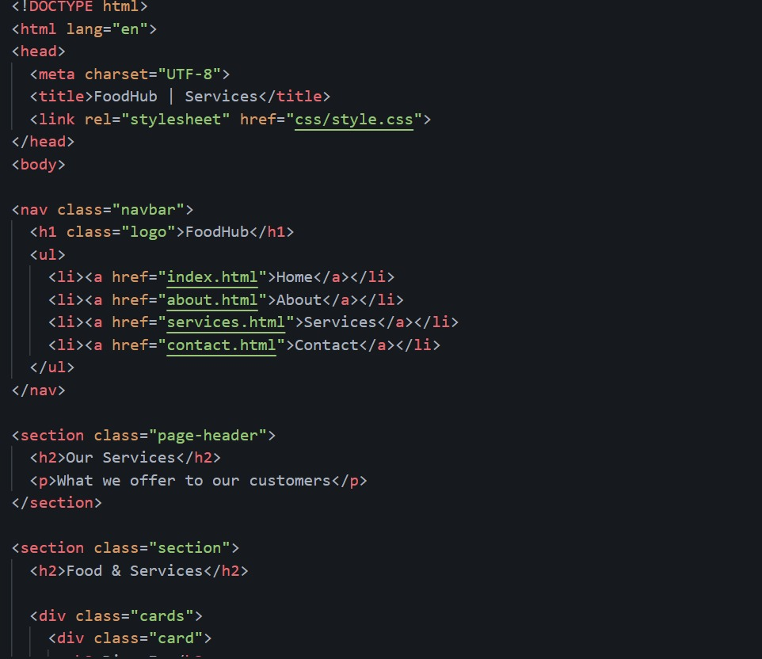

## ***CONTACT:***

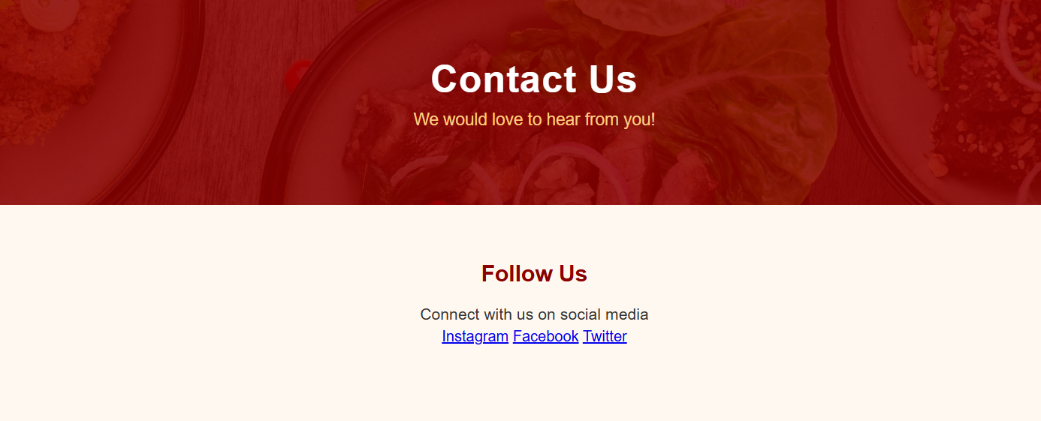

### ***CONTACT.html:***

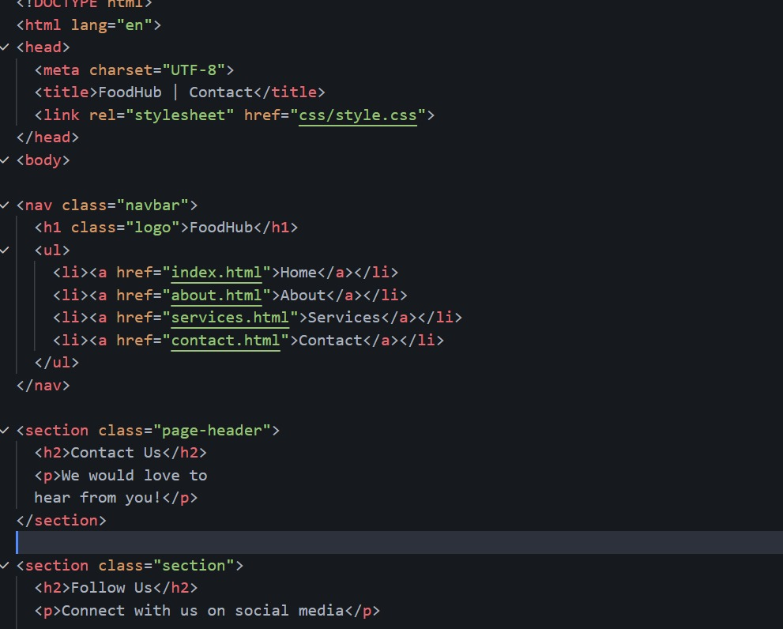

* **Follow Us:** Encourages customers to connect via social media links for Instagram, Facebook, and Twitter.
* **Footer Branding:** Displays the copyright notice "© 2025 FoodHub Restaurant.

# *SQL {Theoretical}:*

## ***Customers:***

### ***Create and insert:***

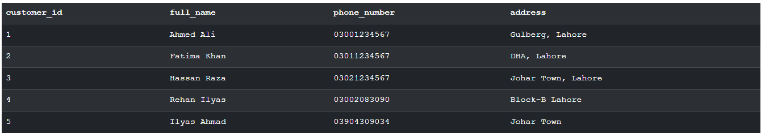

### ***Update:***

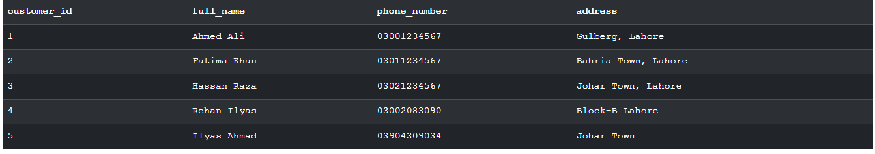

### ***Delete:***

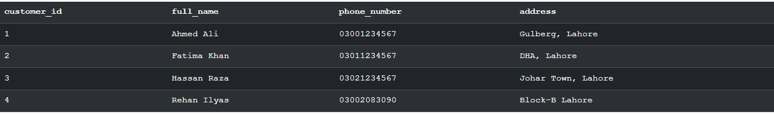

## ***Menu Items:***

### ***Create and insert:***

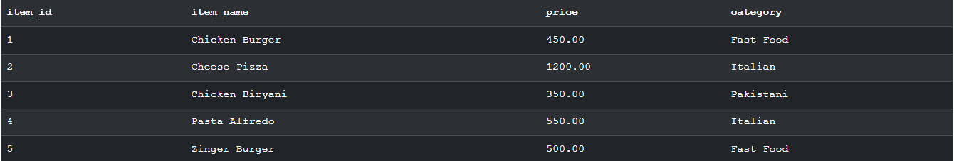

### ***Update:***

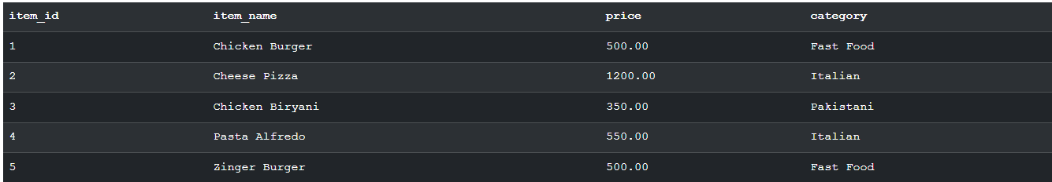

### ***Delete:***

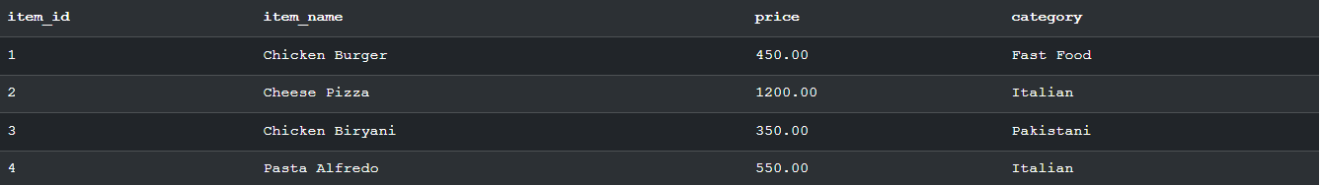

## ***ORDERS STATUS:***

### ***Create and Insert:***

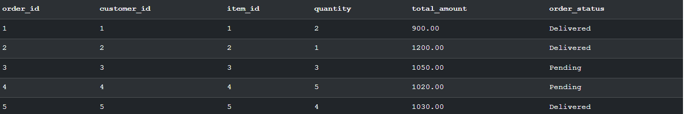

### ***Update:***

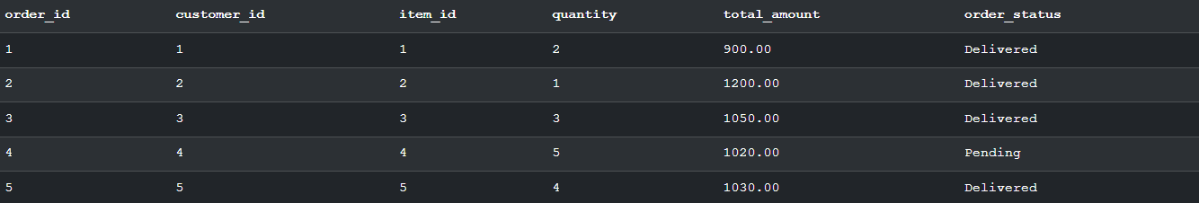

### ***Delete:***

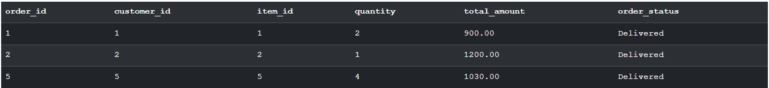

# *SQL Queries:*

## ***TABLE 1:***

### ***Create & Insert:***

This script initializes the Customers table structure and populates it with three initial records. It confirms the successful entry of data by selecting and displaying all rows from the table.

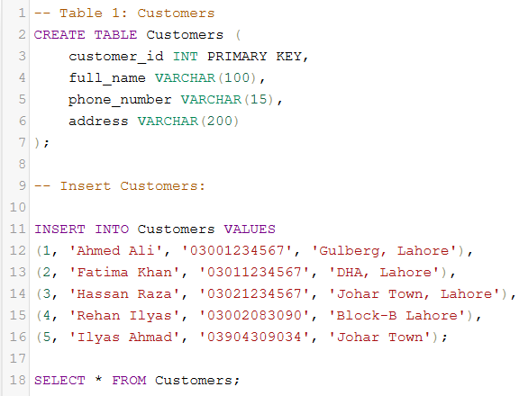

### ***Update & Delete:***

Demonstrates the UPDATE operation. The query modifies the record for customer_id = 1, changing the full_name from "Ahmed Ali" to "Rehan" to reflect a profile correction.

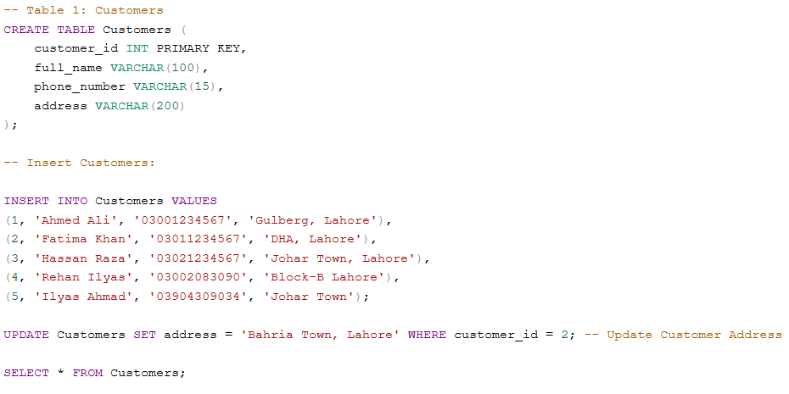

Illustrates the DELETE operation. The query removes the record where customer_id = 1 from the database, effectively deleting that customer's account.

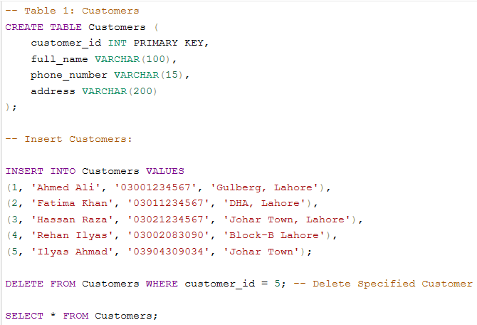

## ***TABLE 2:***

### ***Create & insert:***

Establishes the Menu_Items table schema, defining attributes like price and category. It inserts five distinct food items (Italian, Fast Food, and Pakistani cuisine) and retrieves the full list for verification.

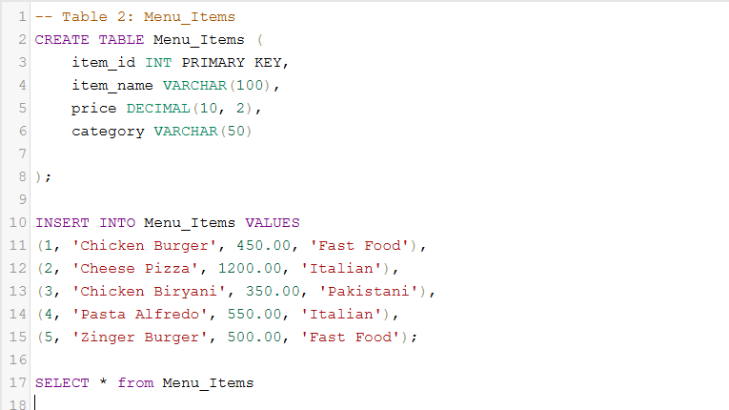

### ***Update & Delete:***

Shows how to modify inventory details. The code updates item_id = 2, replacing "Cheese Pizza" with "Chicken Paratha Roll" using the SET command.

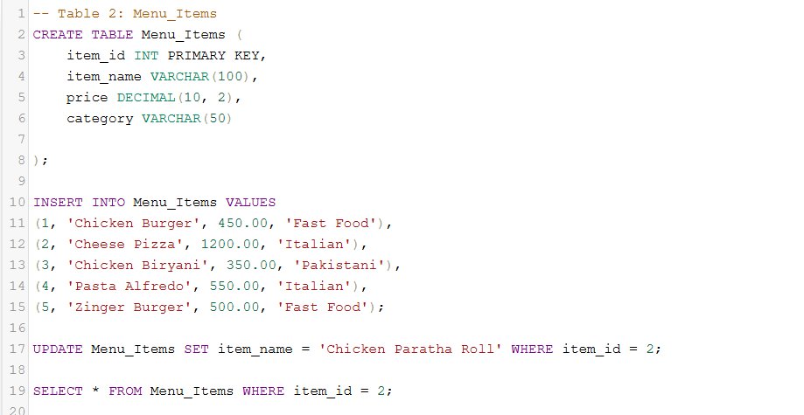

Performs a removal operation on the inventory. The query deletes the item with item_id = 1 (Chicken Burger) from the table, simulating a discontinued menu item.

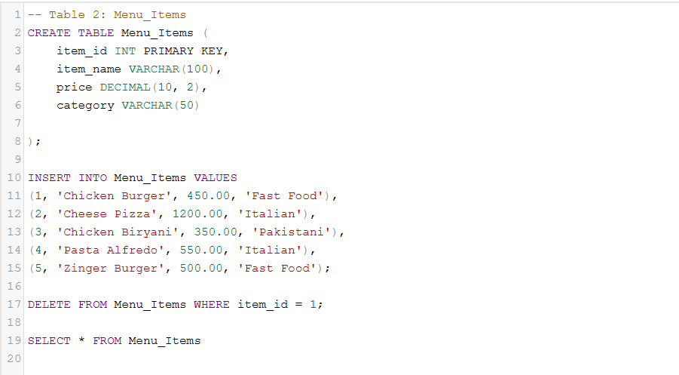

## ***TABLE 3:***

### ***Create & Insert:***

Sets up the Orders table to track transactions. It inserts three sample orders with different statuses ('Delivered' and 'Pending') and calculates the total amounts based on quantity.

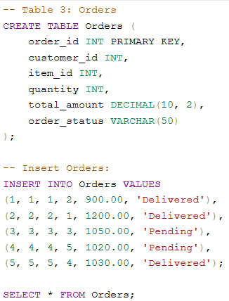

### ***Update & Delete:***

Validaties data correction in transactions. The script updates the total_amount for order_id = 2 to 1000, demonstrating how to fix pricing errors post-entry.

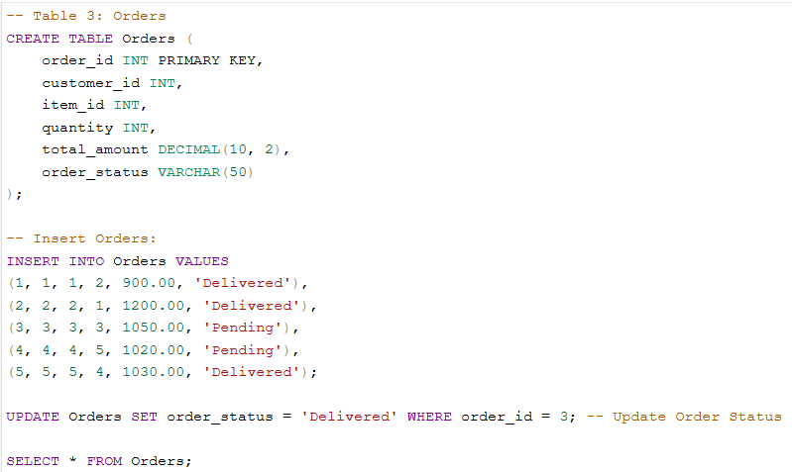

Executing an order cancellation. The script removes the record for order_id = 1 from the system using the DELETE statement.

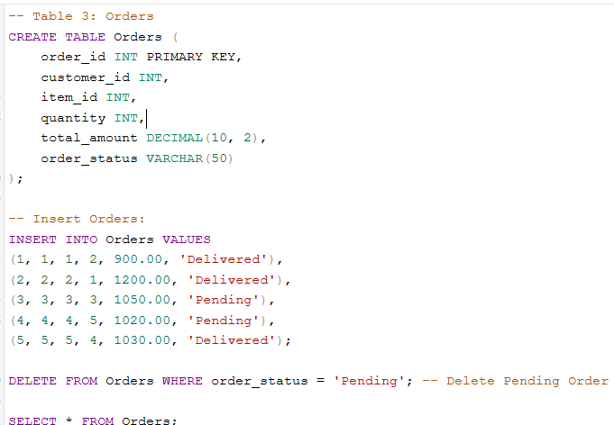

# *COMBINED CSS:*

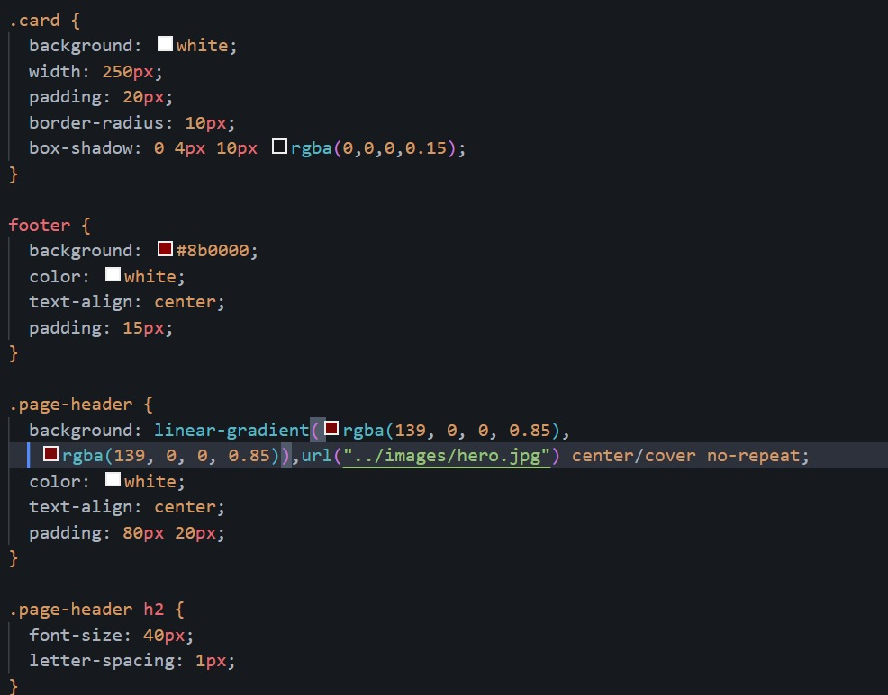

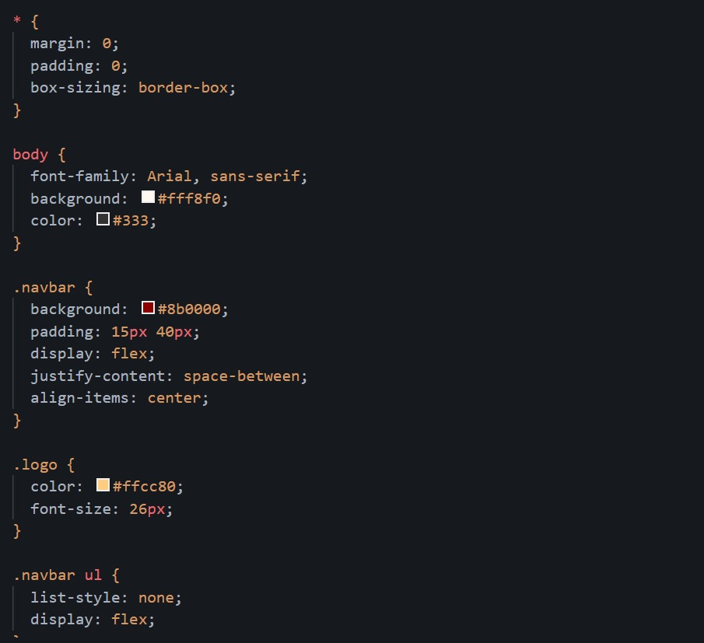

# *Canva designs:*

## ***Banner design:***

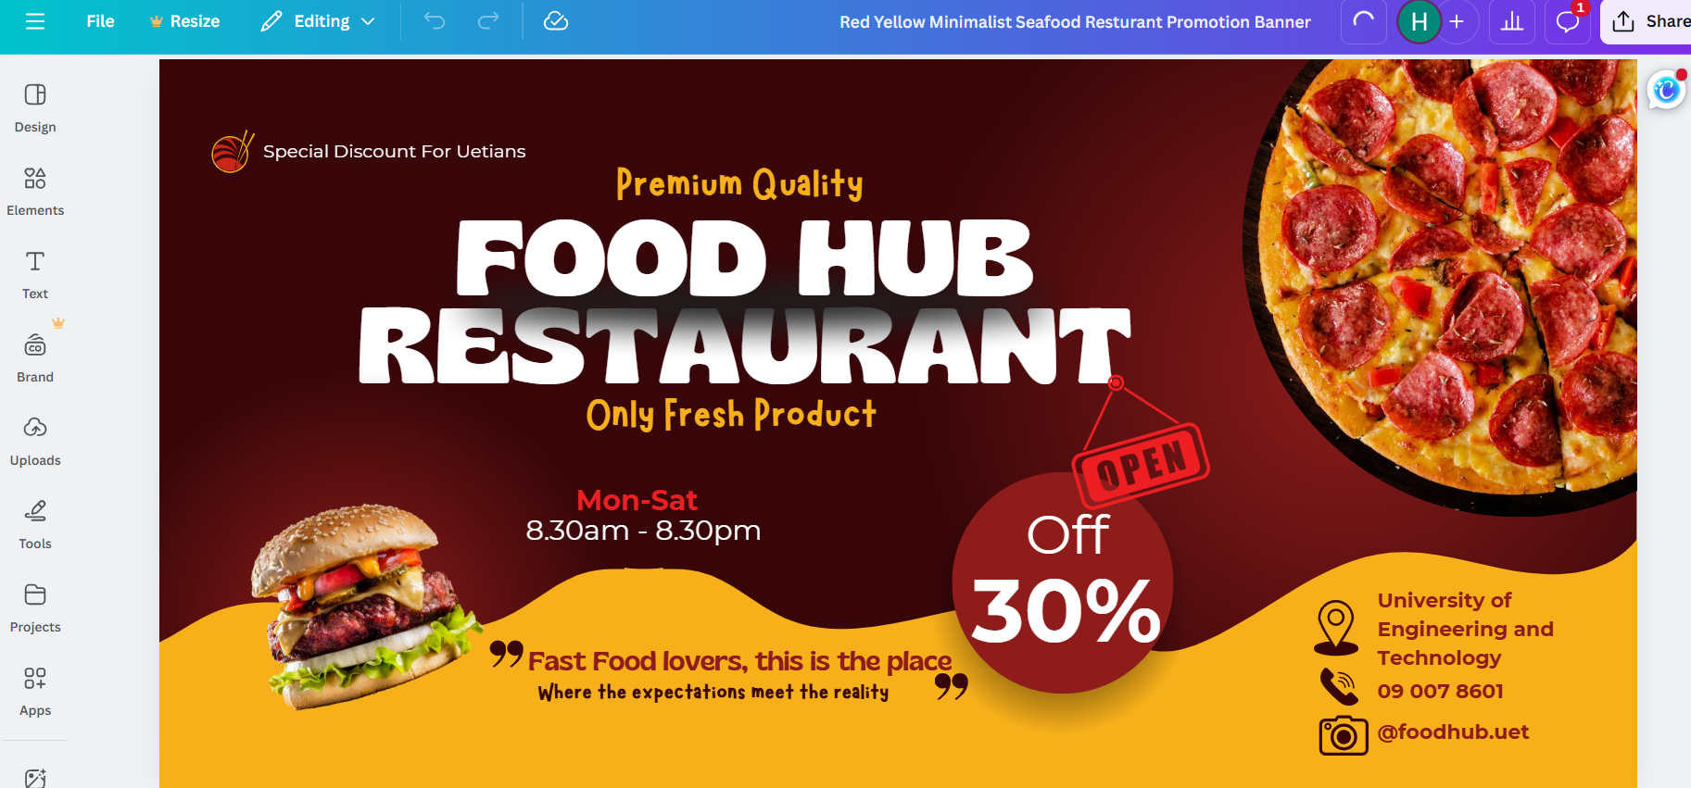

## ***Logo design:***

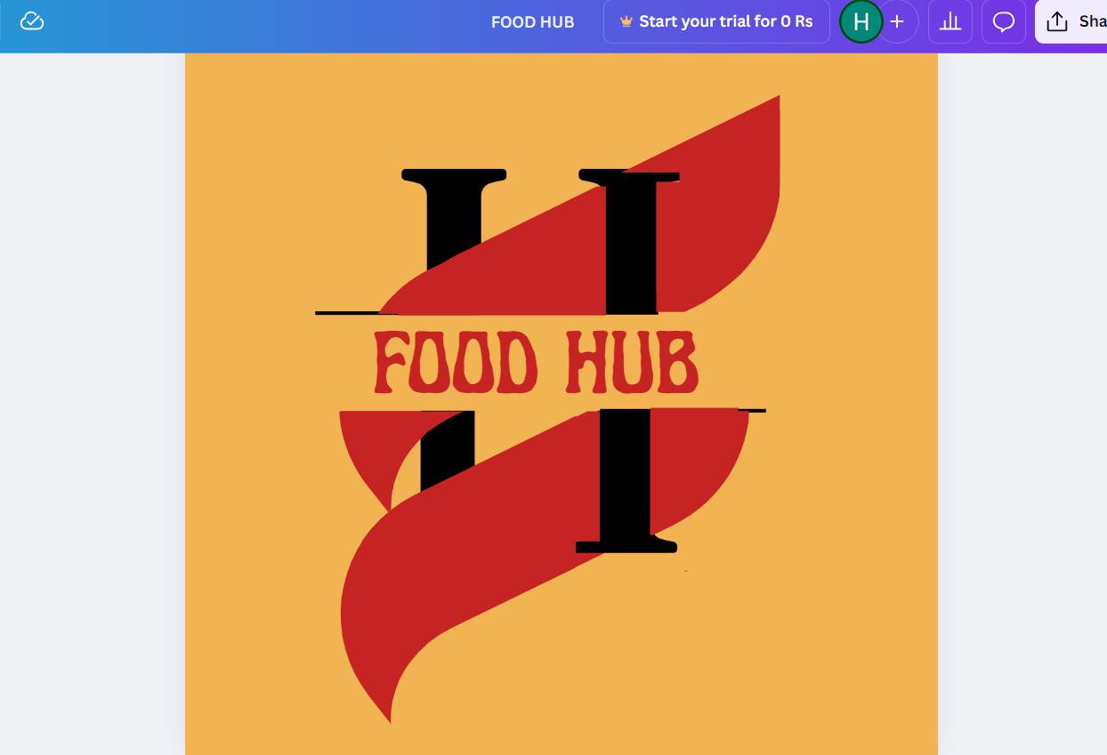

## ***Poster design:***

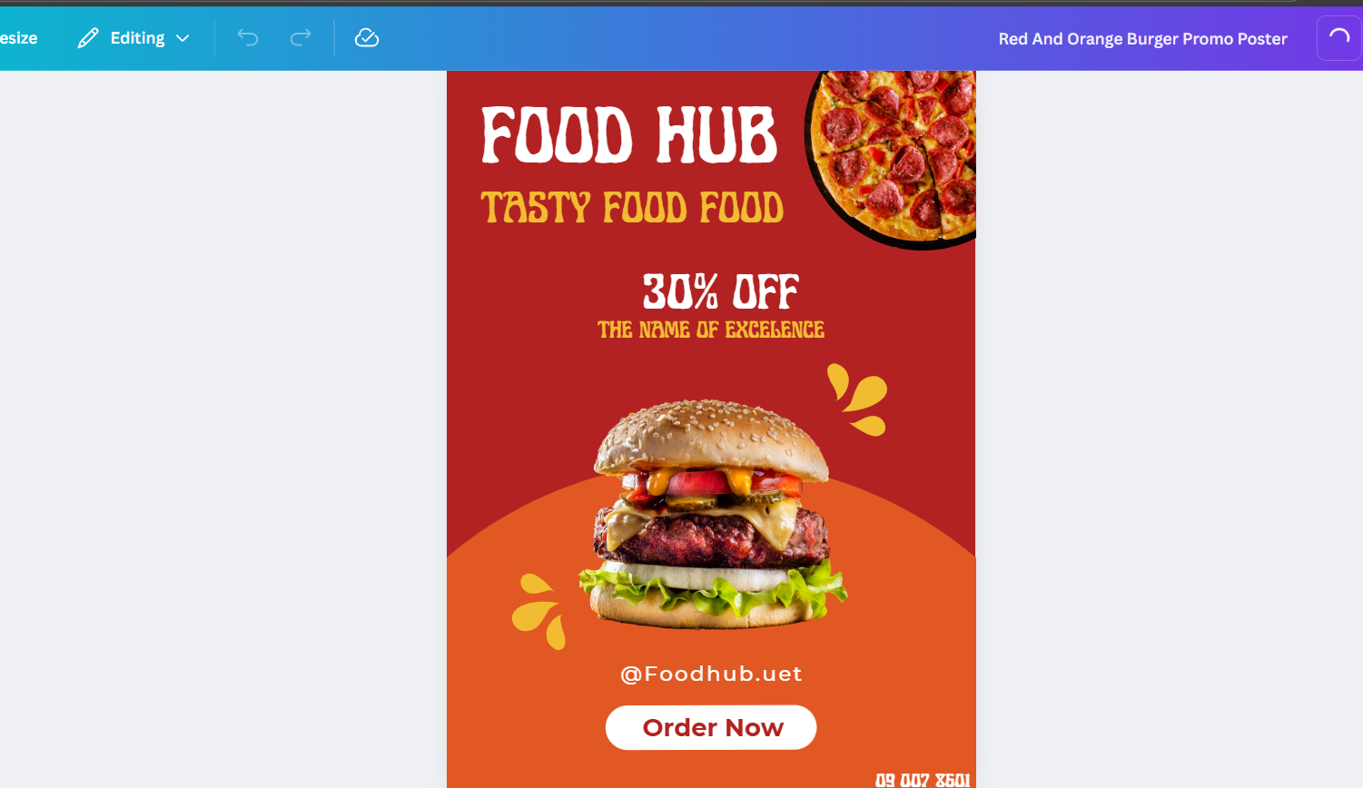

# *GitHub Repository:*

<https://github.com/RehanIlyas-dev/Restaurent-Website-.git>

# *Conclusion:*

The First Semester Project Showcase Website successfully meets all the project requirements. Through this project, basic skills in web development, database concepts, design tools, and version control were learned. This project helped in understanding how different technologies work together to build a complete web-based system.

***THE END***